DevOps Document

**Name:** Tony Jiang

**Semester:** 6

**Class:** RB04

|  |  |  |
| --- | --- | --- |
| Version | Date | Description |
| 0.1 | 28 Oct 24 | Initial document |
| 1 | 8 Dec 24 | Add version 2 |
|  |  |  |

Contents

Introduction 3

CI/CD overview 3

V2 3

V1 4

# Introduction

This document contains the CI/CD pipeline, how it is set up, and the reasons for its configuration.

# CI/CD overview

This document provides an overview of the CI/CD pipeline for the project. It explains how the pipeline is set up, implemented, and versioned, leading to the final product version.

## V2

In this version, the design structure is significantly different from the previous one. Build, Test, Lint, and Snyk now run in parallel, making the CI/CD pipeline faster compared to executing them sequentially. If any of these steps fail, the process will not proceed to Docker. If all four steps pass, Docker is executed, and the build is pushed to the cloud.

The Build task compiles the project to ensure there are no build issues. The Test task runs the unit tests to verify that no tests fail. Lint checks the code for any code smells and ensures the project follows best coding practices. Snyk scans for security vulnerabilities and outdated dependencies. Docker builds the Docker image, publishes it to Docker Hub and finally Cloud, It for deploying to project to cloud.

## V1

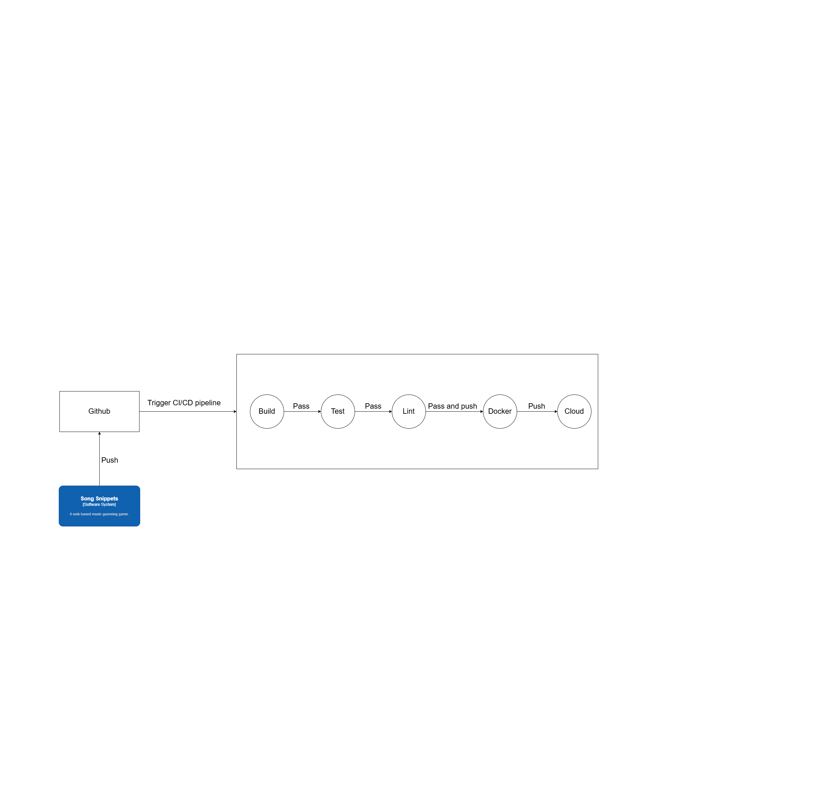

This pipeline is a work in progress and will be enhanced as further research is conducted. The project repository is hosted on GitHub, and GitHub Actions is used to manage the CI/CD pipeline.

The pipeline is triggered whenever changes are pushed to the GitHub repository, regardless of the branch. It begins by building the project and checking for any issues. Next, it runs the existing unit tests to evaluate functionality coverage. Once the tests pass, the pipeline lints the project to identify code issues, code smells, and ensure adherence to best practices.

If all checks are successful, the pipeline pushes the build to Docker and subsequently deploys it to the cloud.